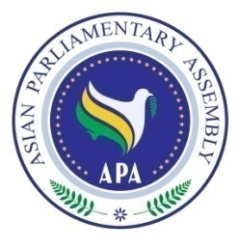

APA Cooperation and Coordination Committee Meeting
At the side of
136th IPU Assembly

Sunday, 2 April 2017
10.00 – 11.00 a.m.
Media Bazar,
on the ground floor of the BICC (venue of the 136th IPU Assembly)

Draft Agenda

- Adoption of the Agenda
- Statement of APA Secretary-General
- Consideration of the Emergency items on the IPU Agenda
- APA events of 2017, preparation and active participation
- Any other matter.

